ROCK PAPER SCISSORS

Your friend designed a game “Rock Paper Scissors”. But it is not working, it needs to be coded to have functionality.

1.
For this exciting part that will make your game functional;
First, create a variable for the computer score and the player score.

2.
Then select your HTML elements.

3.
After that, create an array that contains the rock, the paper, and the scissors icons in order to get them randomly from the array. (You can take icons from class names of html page)

4.
Then, create the game function that contains all the logic, such as getting random icons from the array, putting them on the DOM, and the if statements for each situation(rock against paper, and etc).

5.
That function will run for each button clicked.

Good luck!

HOW TO PLAY – THE RULES

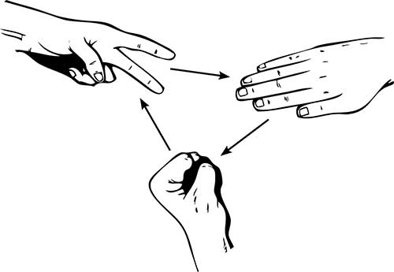
This is a short section for those who do not know how to play the game, or maybe forgotten how rock, paper, scissors work.

It is a simple game for 2 players.
- Each you and your competitor picks rock, paper, or scissors together at the same time.
- Scissors will beat paper but lose to rock.
- Paper will beat rock but loses to scissors.
- Rock will beat scissors but loses to paper.

